DNA duplex stability

CONTENTS
- 1Introduction
- 2Factors influencing DNA duplex stability
  - 2.1Hydrogen bonding
  - 2.2Base stacking
- 3Thermodynamics of DNA duplex formation
  - 3.1Non self-complementary DNA
  - 3.2Self-complementary DNA
- 4Experimental determination of DNA duplex stability
  - 4.1UV melting
  - 4.2Calorimetry
- 5Prediction of DNA duplex stability
- 6Tuning DNA duplex stability
  - 6.1Nucleic acid analogues
  - 6.2Modified bases
    - 6.2.1AP-dC (G-clamp)
    - 6.2.22-Aminoadenine
    - 6.2.3Other modified bases

INTRODUCTION
The stability of the DNA double helix depends on a fine balance of interactions including hydrogen bonds between bases, hydrogen bonds between bases and surrounding water molecules, and base-stacking interactions between adjacent bases.
Slight variations in the DNA sequence can have profound implications on the stability of the DNA duplex. For example, mutations in the base sequence that result from errors that occur during DNA replication can result in mismatches that lead to relatively unstable duplexes. This instability is exploited by proofreading enzymes which recognize the mutation and replace it with the correct nucleotide (see Mutagenesis and DNA repair).
To gain an insight into DNA duplex stability, and how it is affected by changes in primary structure, scientists have studied the structure and thermodynamic stability of a variety of DNA duplexes by using a combination of physical methods including X-ray crystallography, ultraviolet (UV) melting and NMR.

FACTORS INFLUENCING DNA DUPLEX STABILITY
DNA duplex stability is determined primarily by hydrogen bonding, but base stacking also plays an important role.

Hydrogen bonding
The heterocyclic bases of single-stranded DNA have polar amido, amidino, guanidino and carbonyl groups that form a complex network of hydrogen bonds with the surrounding water molecules. Some of these bonds must be broken during duplex formation as the inter-base hydrogen bonds are formed. The overall process is one of "hydrogen bond exchange" and the net change in enthalpy upon duplex formation is partly due to ∆H(H-bonds formed) − ∆H(H-bonds broken). For duplexes of any significant length this is an exothermic process at ambient temperature. Not surprisingly the coming together of two large oligomeric molecules is entropically unfavourable (∆S is negative).

Base stacking
Inter-strand hydrogen bonding is clearly important in driving the formation of DNA duplexes, but it is by no means the only contributing factor. The individual bases form strong stacking interactions which are major contributors to duplex stability, as base stacking is much more prevalent in duplexes than in single strands (Figure 1). Base-stacking interactions are hydrophobic and electrostatic in nature, and depend on the aromaticity of the bases and their dipole moments. Base-stacking interactions in nucleic acid duplexes are partly inter-strand and partly intra-strand in nature. However, it is probably more informative to consider base pairs rather than individual bases as discrete units in order to visualize the stabilizing effects of base stacking.
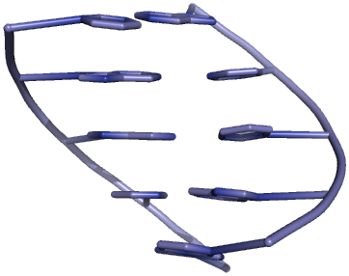
Figure 1 | Cartoon representation of base stacking in a DNA double helix
The degree of stabilization afforded by base stacking depends on the DNA sequence. Some combinations of base pairs form more stable interactions than others, so nearest neighbour base-stacking interactions are important determinants of duplex stability.
Base-stacking interactions increase with increasing salt concentration, as high salt concentrations mask the destabilizing charge repulsion between the two negatively charged phosphodiester backbones. DNA duplex stability therefore increases with increasing salt concentration. Divalent cations such as Mg²⁺ are more stabilizing than Na⁺ ions, and some metal ions bind to specific loci on the DNA duplex.

THERMODYNAMICS OF DNA DUPLEX FORMATION

Non self-complementary DNA
When two complementary (but not self-complementary) strands of DNA are mixed in solution, an equilibrium is rapidly established between the single strands, A_{ss} and B_{ss}, and the (double-stranded) duplex, C_{ds}:
A_{ss} + B_{ss} ⇌ C_{ds}
Eliminating ∆_{r}G, the change in Gibbs energy for the forward reaction (duplex formation), from the thermodynamic equations
∆_{r}G = −RT ln K_{eq}
and
∆_{r}G = ∆_{r}H − T∆_{r}S
gives the van't Hoff equation:
− ln K_{eq} = (∆_{r}H / RT) − (∆_{r}S / R)
This can be rearranged to give
1 / T = − (R / ∆_{r}H) ln K_{eq} + ∆_{r}S / ∆_{r}H)
in which ∆_{r}H is the enthalpy change, ∆_{r}S is the entropy change, R is the gas constant and K_{eq} is the equilibrium constant.
The equilibrium constant K_{eq} can be written as a function of the extent of association, α, and of the initial total concentration of single-stranded DNA, C_{T} (C_{T} = [A_{ss}]_{initial} + [B_{ss}]_{initial}). At equilibrium there are 1−α moles of A_{ss}, 1−α moles of B_{ss} and α moles of C_{ds}, so
K_{eq} = ([C_{ds}]_{eq} / [A_{ss}]_{eq}[B_{ss}]_{eq}) = (x_{C}C_{T} / x_{A}C_{T}x_{B}C_{T}) = 2α / [(1−α)²C_{T}]
At the midpoint of the melting curve, α = ½, so
K_{eq} = (1 / ¼C_{T}) = (4 / C_{T})
therefore
− ln K_{eq} = − ln (4 / C_{T}) = ln (C_{T} / 4)

Self-complementary DNA
For self-complementary DNA, an equilbrium is established in solution between single-stranded and double-stranded DNA:
2 A_{ss} ⇌ C_{ds}
As with non self-complementary DNA, the equilibrium constant K_{eq} can be written as a function of the extent of association, α, and of the initial concentration of single-stranded DNA, C_{T} (C_{T} = [A_{ss}]_{initial}). At equilibrium there are 1−α moles of A_{ss} and α moles of C_{ds}, so
K_{eq} = ([C_{ds}]_{eq} / [A_{ss}]_{eq}²) = (x_{C}C_{T} / x_{A}²C_{T}²) = α / [2(1−α)²C_{T}]
At the midpoint of the melting curve, α = ½, so
K_{eq} = (1 / C_{T})
therefore
− ln K_{eq} = − ln (1 / C_{T}) = ln (C_{T})

EXPERIMENTAL DETERMINATION OF DNA DUPLEX STABILITY

UV melting
Heating double stranded nucleic acids causes the strands to unwind (denature) by disrupting the ordered stacking of the bases and breaking hydrogen bonds. The process can be conveniently monitored by an increase in UV absorbance as the double strands unwind to single strands (owing to hypochromicity). The thermal denaturation of double-stranded DNA is progressive and the concerted melting of the whole structure occurs at a well-defined temperature, corresponding to the mid-point of a smooth transition. This temperature is known as the melting temperature (T_{m}).
The example in Figure 2 shows a melting curve (UV absorption as a function of temperature). Slow heating of double-stranded DNA causes the unwinding of the ordered helical structure into the two single-stranded constituents. This can be seen as a sigmoidal curve of increasing UV absorption. The mid-point, corresponding to the precise melting temperature (T_{m}) of the duplex, is indicated.
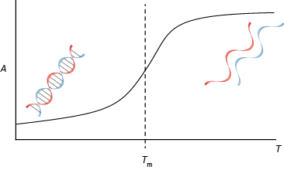
Figure 2 | A typical UV melting curve
To determine thermodynamic parameters, samples are made up at different concentrations, each containing equal amounts of two complementary sequences of DNA (A_{ss} and B_{ss}) in a salt/buffer solution. On mixing at ambient temperature the two strands of DNA spontaneously form a duplex (C_{ds}) (i.e. α = 1) (this is true for DNA strands of any reasonable length). Each sample is heated in a UV spectrometer from 20 ºC to (say) 80 ºC at a rate of one degree per minute and the absorbance is monitored as shown in Figure 2. The melting temperature, T_{m}, is the temperature at the maximum absorbance gradient (dA/dT) and corresponds to 50% association (α = ½). The graph (Figure 3) shows the relationship between absorbance and concentration and illustrates the slight increase in T_{m} with increasing DNA concentration.
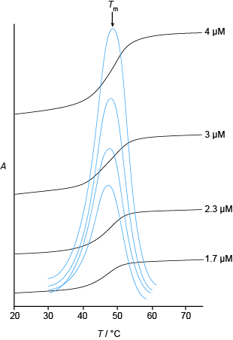
Figure 3 | UV melting curves and derivatives
Since α = ½,
1 / T_{m} = (R / ∆_{r}H) ln (C_{T} / 4) + (∆_{r}S / ∆_{r}H)
A graph of 1/T_{m} against ln(C_{T}/4) therefore has a gradient R/∆_{r}H and an intercept ∆_{r}S/∆_{r}H (neglecting the temperature-dependence of ∆_{r}S and ∆_{r}H ). The reciprocals of the recorded T_{m} values are plotted against the ln(C_{T}/4) values and linear regression is used to determine ∆_{r}H and ∆_{r}S. Finally, ∆_{r}G is evaluated. Figure 4 shows such a van't Hoff plot:
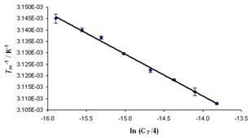
Figure 4 | Van’t Hoff plot for the duplex dGGCTATCTATCTGC-dGCAGATATATAGCC (containing a C-T mismatch) giving ∆_{r}H= −453.5 kJ mol-1, ∆_{r}S = −1295 J K⁻¹ mol⁻¹ and ∆_{r}G = −52.01 kJ mol⁻¹ (at 298K)

Calorimetry
Calorometry is an classically important method for measuring DNA duplex stability, although UV melting has proved more popular owing the available of UV spectrometers with temperature-controlled sample chambers, and the relative ease of recording T_{m} values. Whereas UV melting provides an indirect method for measuring ∆_{r}H, ∆_{r}S and ∆_{r}G for melting, calorimetry allows more direct measurement of these thermodynamic parameters.

PREDICTION OF DNA DUPLEX STABILITY
The melting temperature (T_{m}) of a DNA duplex and the effect of salt can be predicted using the formula
T_{m} = 81.5 + 16.6 × (−1) + 41 × (nG + nC) / (nA + nG + nC + nT) − 675 / (nA + nG + nC + nT)
However, this formula only applies to DNA duplexes containing exclusively Watson-Crick A.T and G.C base pairs under a well-defined set of conditions, and cannot be used to determine the melting temperatures of mismatch-containing duplexes.

TUNING DNA DUPLEX STABILITY
When designing and synthesizing synthetic DNA oligonucleotides, for example for use in antisense therapy or as PCR probes, it is often desirable to either increase or decrease the stability of the duplex formed on binding to complementary DNA.

Nucleic acid analogues
Artificial nucleic acid analogues bind to complementary DNA. Peptide nucleic acid (PNA), a neutral molecule, forms particularly strong and specific interactions with DNA. Stretches of PNA can be incorporated into DNA oligonucleotides to increase duplex stability; but care must be taken in desigining the PNA-DNA junction, and the stablizing effect of the PNA can be offset by the destabilizing impact of the junction. Locked nucleic acid (LNA) and unlocked nucleic acid (UNA) are analogues of RNA that can be easily incorporated into DNA oligonucleotides during solid-phase oligonucleotide synthesis, and respectively increase and decrease duplex stability. LNA and UNA phosphoramidite monomers are not readily available, however, and it is not always easy to predict the effect of incorporating LNA and UNA units into DNA oligonucleotides before they are synthesized.

Modified bases
Modified DNA bases that increase the stability of base pairs (and therefore the duplex as a whole) have been developed. These modified bases can be incorporated into oligonucleotides during solid-phase synthesis and offer a more predictable method of increasing DNA duplex stability.

AP-dC (G-clamp)
AP-dC (G-clamp) is a tricyclic analogue of cytosine. Like cytosine, G-clamp forms base pairs with guanine; but, while G·C base pairs are stabilized by three hydrogen bonds, G·G-clamp base pairs have four hydrogen bonds (Figure 5). The extra hydrogen bond can lead to an increase in T_{m} of 18 °C. The incorporation of multiple G-clamp bases can result in further increases in duplex stability.
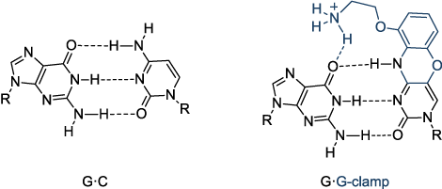
Figure 5 | Structure of the G·G-clamp base pairG·G-clamp base pairs (right) increase the stability of a DNA duplex by up to 18 °C relative to G·C base pairs (left).

2-Aminoadenine
2-Aminoadenine forms base pairs with thymine that are stabilized by three hydrogen bonds (one more than the two hydrogen bonds of A·T base pairs) (Figure 6). Each substitution of an A·T base pair by a 2-aminoadenine·thymine base pair increases the stability of the duplex by about 3 °C.
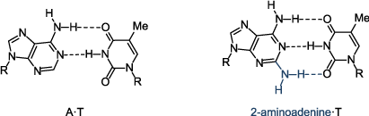
Figure 6 | Structure of the 2-aminoadenine·thymine base pair2-aminoadenine·thymine base pairs (right) increase the stability of a DNA duplex by around 3 °C (per substitution) relative to A·T base pairs (left).

Other modified bases
Modest increases in duplex stability have been observed with other modified bases, including 5-methylcytosine and C(5)-propynylcytosine (replacing cytosine), and C(5)-propynyluracil (replacing thymine).

SEE ALSO
- Mutagenesis and DNA repair
- Ultraviolet absorbance of oligonucleotides
- Oligonucleotides as drugs
- Sequencing, forensic analysis and genetic analysis
- Nucleic acid analogues
- Solid-phase oligonucleotide synthesis
Our free online Nucleic Acids Book contains information on all aspects of nucleic acids chemistry and biology.

